**LAB 6: CREATING A BUSINESS CARD USING MACROMEDIA FLASH 8**

Creating a business card in Macromedia Flash 8 is a relatively straightforward process. Here are simple steps to get you started:

1. **Open Macromedia Flash 8**: Launch the software on your computer.

2. **Create a New Document**: Go to "File" > "New" to create a new Flash document.

3. **Set Document Properties**: Adjust the document properties, such as size and background color, by going to "Modify" > "Document." Set the dimensions for your business card (typically 3.5 x 2 inches for a standard card).

4. **Design Your Business Card**: Use the drawing tools and text tool to design your business card. Add your company logo, contact information, and any other relevant details. Customize fonts, colors, and graphics as desired.

5. **Organize Layers**: Organize your design elements on different layers to make editing and animating easier. You can create layers by going to "Insert" > "Layer."

6. **Add Interactivity (Optional) **: If you want to add interactive elements like clickable links or buttons use the Action Script programming language. You can access the Action Script panel by going to "Window" > "Actions."

7. **Test Your Business Card**: Before exporting, test your business card by going to "Control" > "Test Movie" to preview the interactive elements and animations (if any).

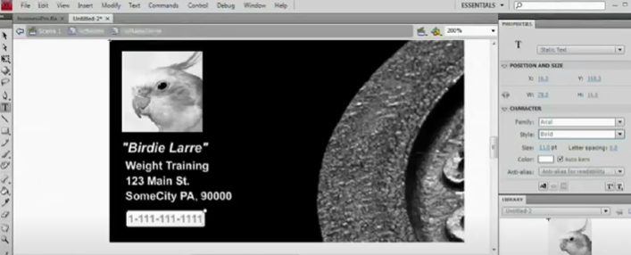8. **Export Your Business Card**: Finally, go to "File" > "Publish" to export your business card as a SWF (Shockwave Flash) file that you can share digitally. You can also export it as video or other formats if needed.

